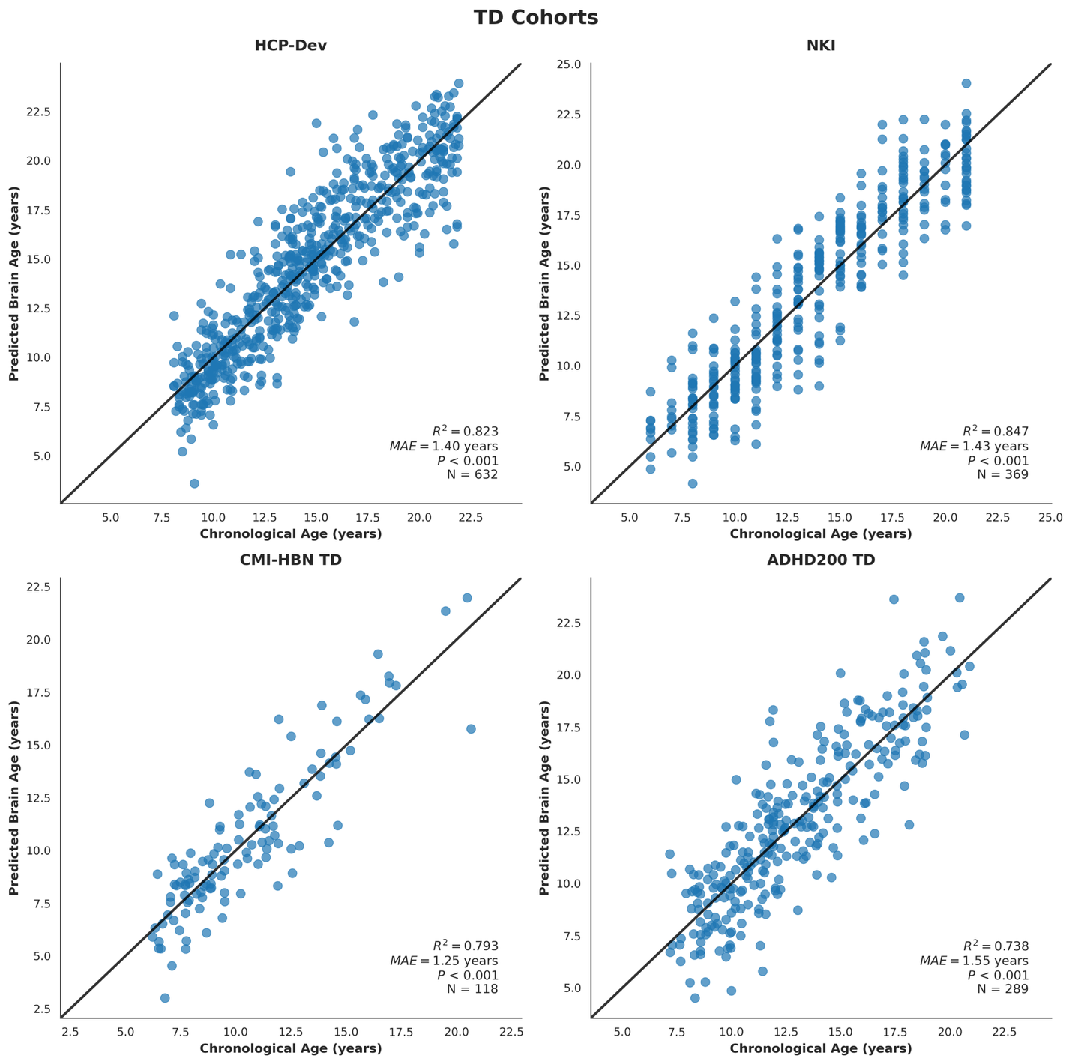

**Figure 1.** **Brain age prediction in typically developing (TD) youth.** Our model achieved high prediction accuracy in the **(A)** HCP-Development discovery cohort and three independent validation cohorts including **(B)** NKI-RS, **(C)** CMI-HBN (TD subset), and **(D)** ADHD-200 (TD subset), demonstrating robust cross-dataset generalization in brain age prediction.

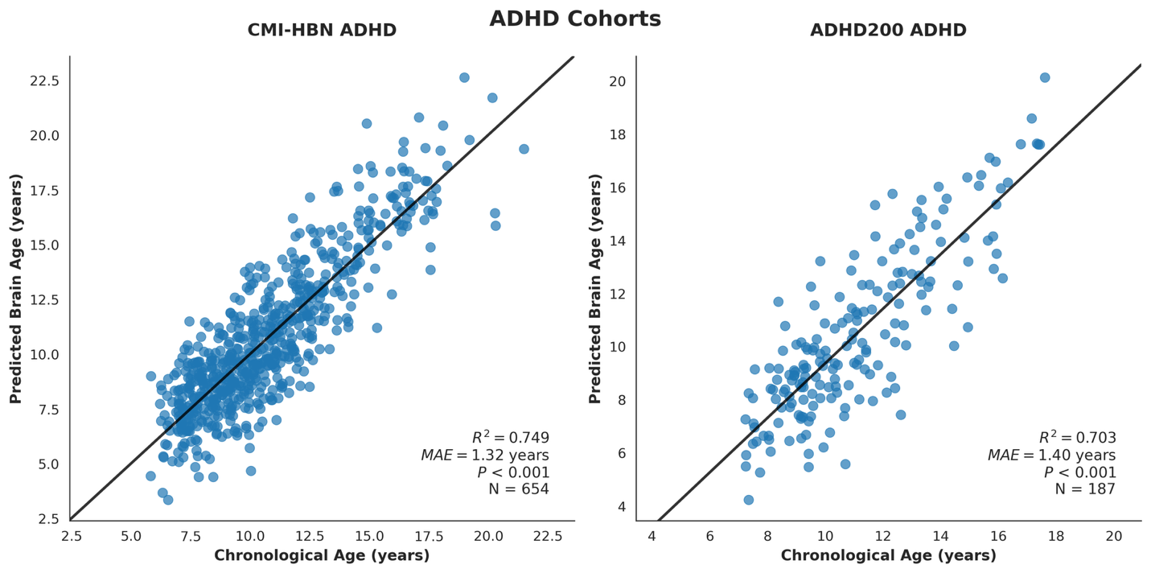

**Figure 2.** **Brain age prediction in individuals with ADHD.** Our model trained on the HCP-Development cohort achieved high prediction accuracy in individuals with ADHD from **(A)** CMI-HBN and **(B)** ADHD-200 cohorts, suggesting that our normative model generalized robustly to clinical populations.

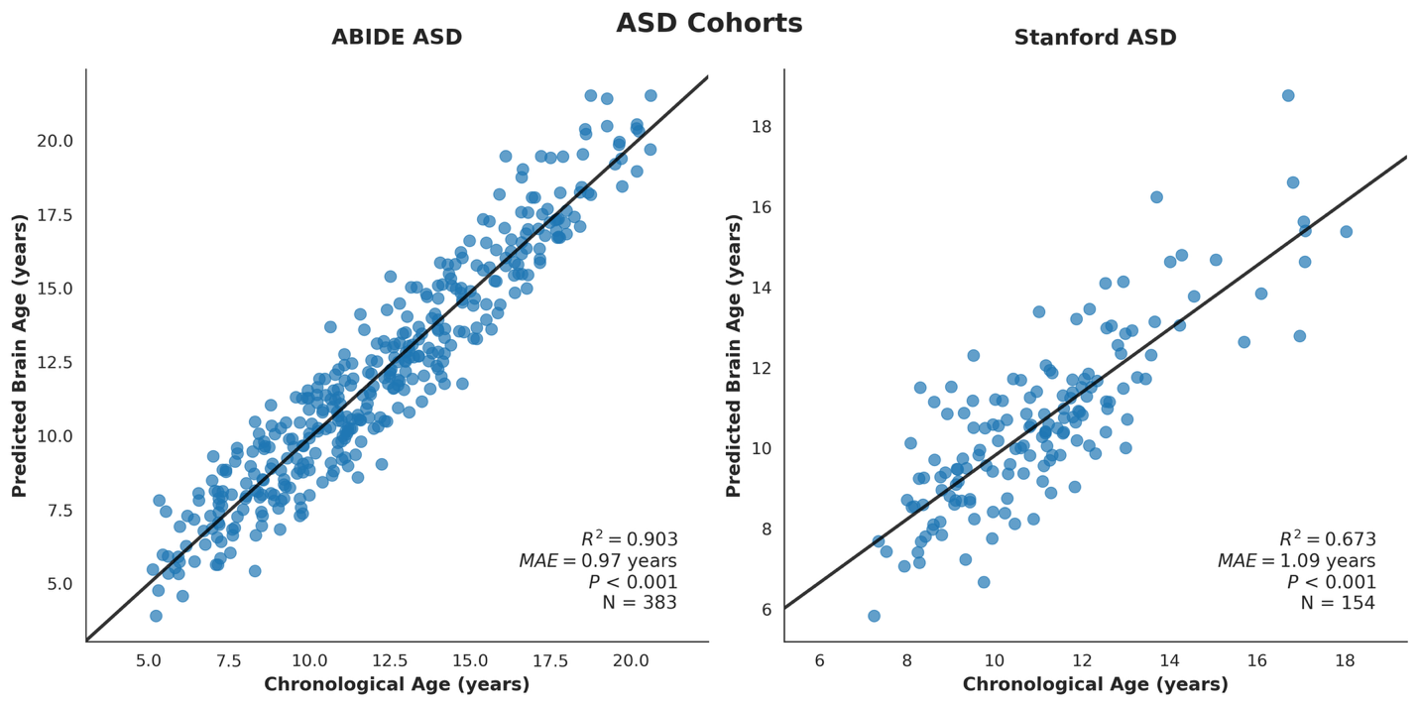

**Figure 3. Brain age prediction in individuals with ASD.** Our model trained on the HCP-Development cohort achieved high prediction accuracy in individuals with ASD from the **(A)** ABIDE and **(B)** Stanford cohorts, suggesting that our normative model generalized robustly to clinical populations.

**Figure 4. TD developmental fingerprints revealed by explainable AI.** Integrated Gradient maps in **(A)** HCP-Development, **(B)** NKI-RS, **(C)** CMI-HBN, and **(D)** ADHD-200 cohorts identify brain regions most influential for age prediction in typically developing youth. Brain regions identified as significant predictors of brain age through Integrated Gradients analysis. Highlighted regions include the inferior parietal lobule (IPL), frontal pole (FP), hippocampus (HC), and insula (INS). (**C)** Convergent high-saliency regions across cohorts indicates the model captures robust patterns of healthy brain maturation.

**Figure 5. ADHD developmental fingerprints revealed by explainable AI.** Integrated Gradients maps in **(A)** CMI-HBN and **(B)** ADHD-200 cohorts identify brain regions most influential for age prediction in ADHD. Shared high-saliency regions across cohorts, including default mode network (medial prefrontal cortex, anterior cingulate), memory network (hippocampal and parahippocampal region) and frontoparietal control, point to stable ADHD signature relative to typical developing norms. **(C)** convergence indicates the model captures ADHD-related developmental differences, not dataset or site artifacts.

**Figure 6.** **ASD developmental fingerprints revealed by explainable AI.** Integrated Gradients maps in **(A)** ABIDE and **(B)** Stanford cohorts identify brain regions most influential for age prediction in ASD. **(C)** Shared high-saliency regions across cohorts, including default mode network (medial prefrontal cortex, posterior cingulate, precuneus), executive control (dorsolateral prefrontal) and memory (hippocampal / parahippocampal), point to stable ASD signature relative to typical developing norms. Furthermore, this convergence indicates the model captures ASD-related developmental differences, not dataset or site artifacts.

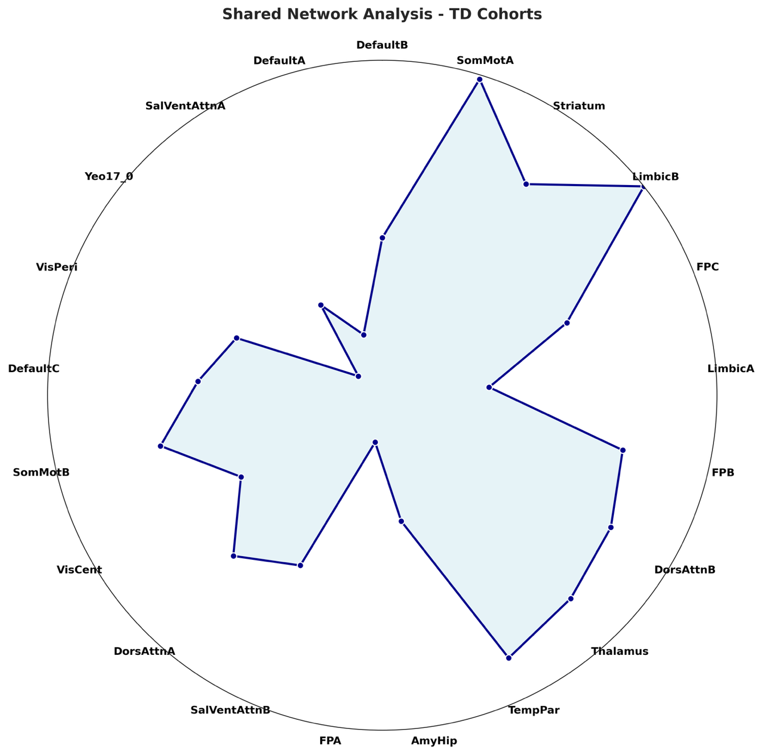

**Figure 7: Radar plot showing networks consistently identified as top predictors of aging in typically developing individuals.**

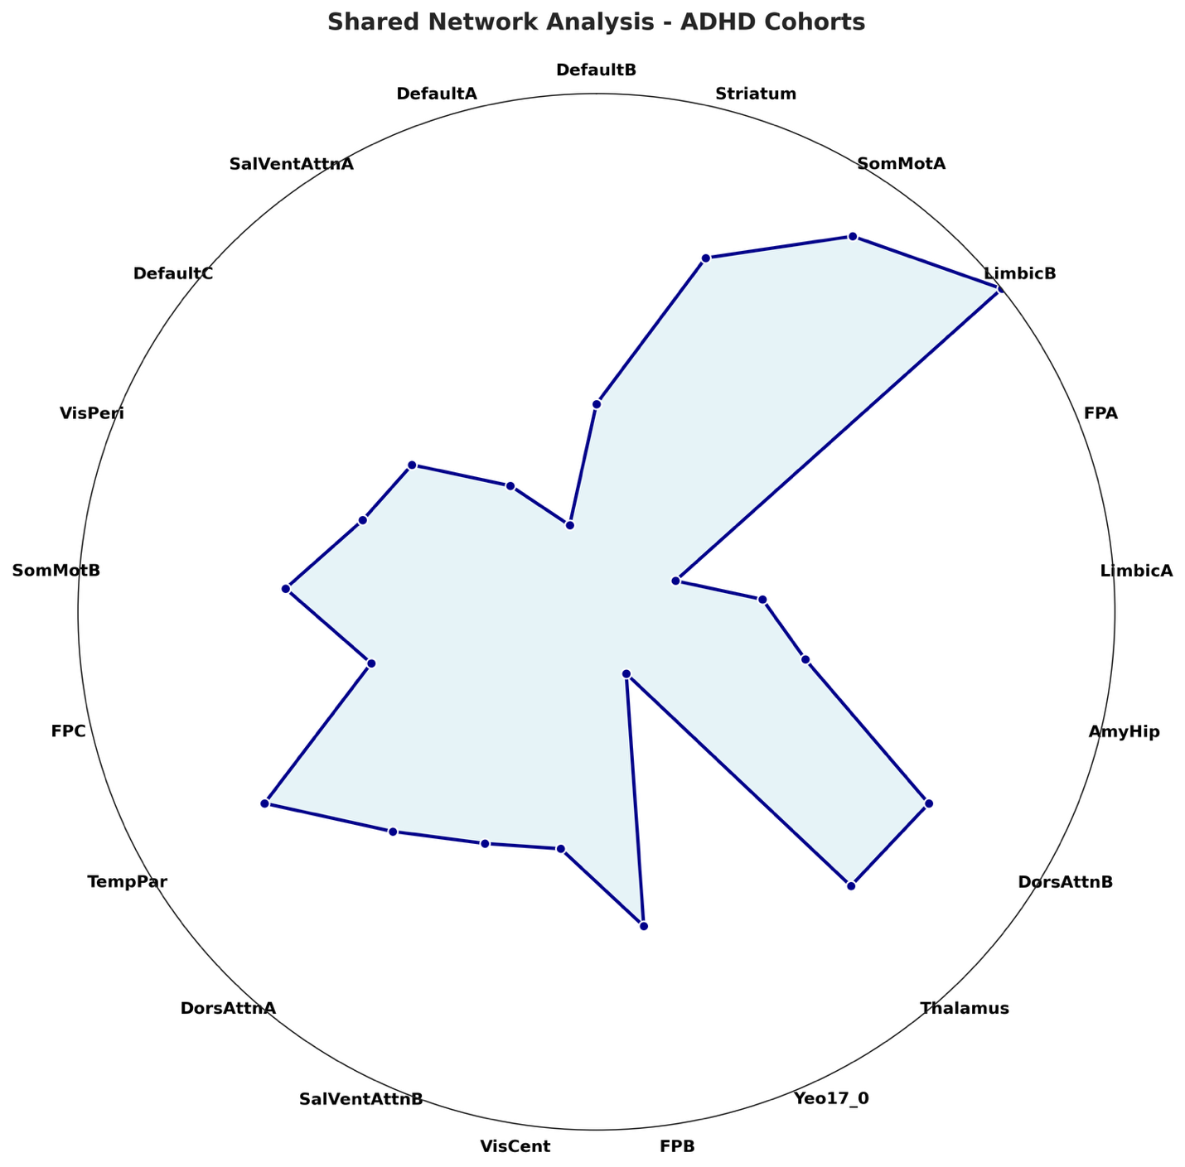

**Figure 8: Radar plot showing networks consistently identified as top predictors of aging in ADHD individuals.**

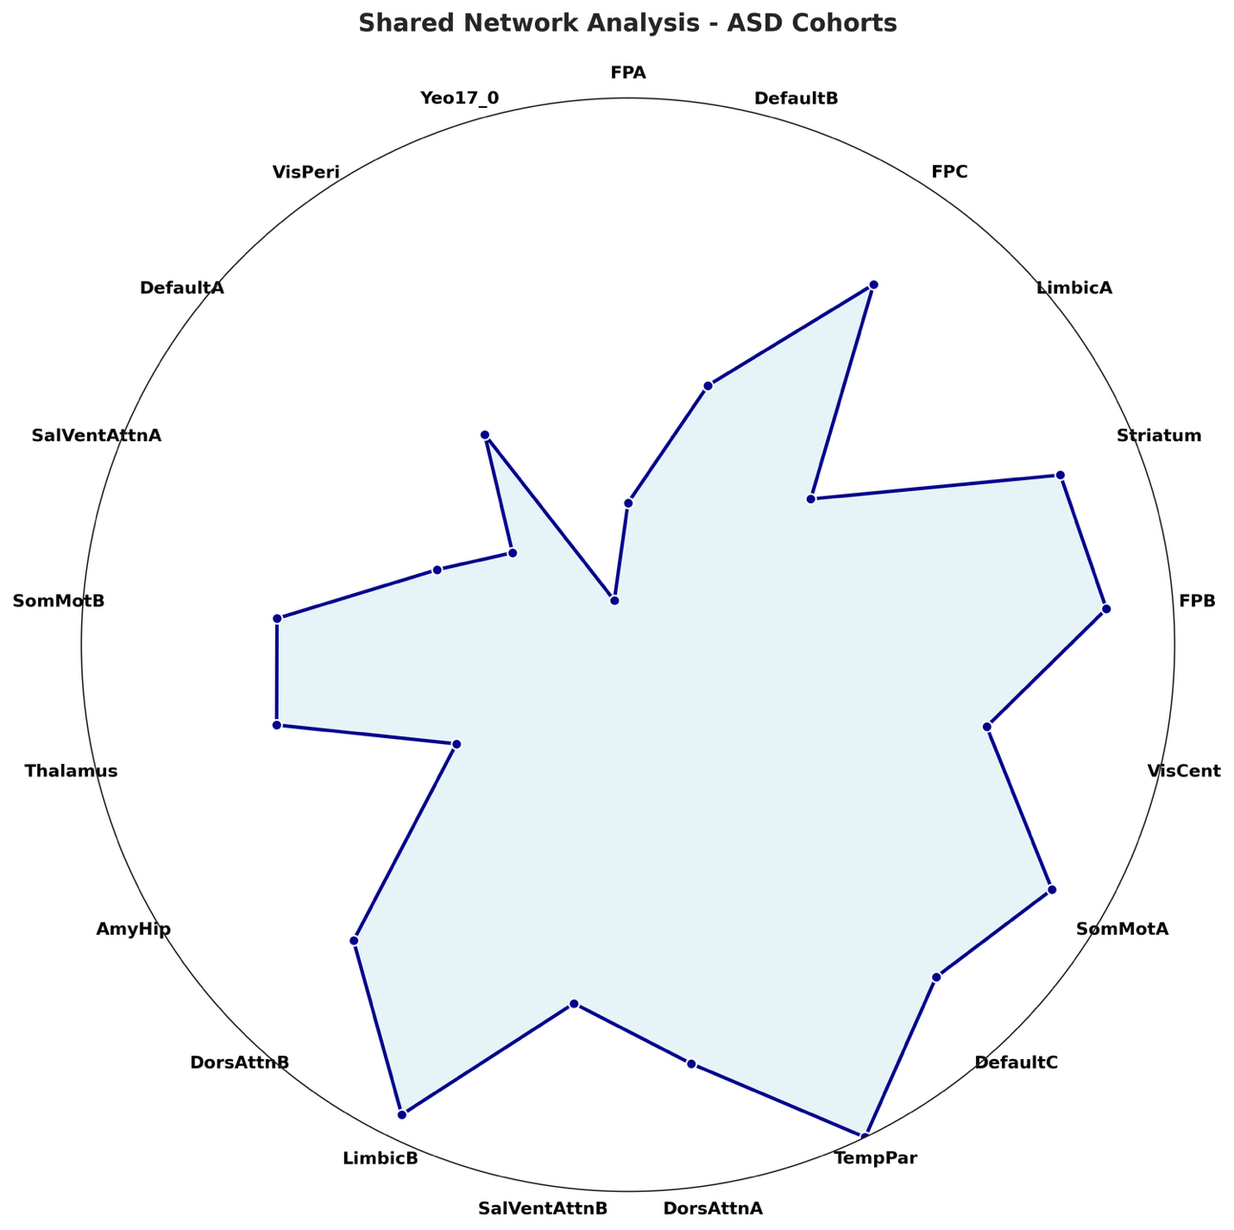

**Figure 9: Radar plot showing networks consistently identified as top predictors of aging in ASD individuals.**

(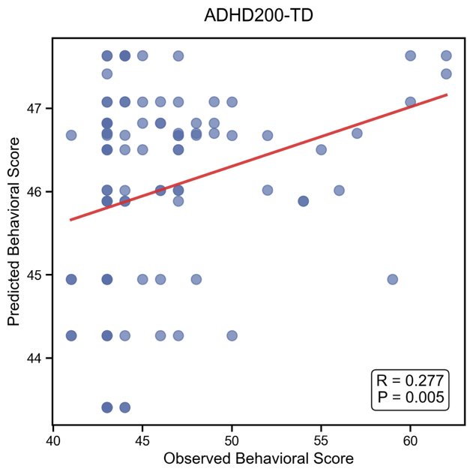 (HY)

**Figure 7. Brain fingerprints predict ADHD traits in typically developing youth.** In NKI-RS cohort, subject-level fingerprints significantly predict **(A)** Hyperactivity and **(B)** Inattention, indicating a reliable link between normative developmental patterns and subclinical symptom variation. Significant prediction of hyperactivity in ADHD-200 TD subset also achieved.

**Figure 8**. **Brain fingerprints predict ADHD symptom severity in individuals with ADHD.** Individual fingerprints significantly predict **(A)** Hyperactivity and **(B)** Inattention scores in the ADHD-200 and CMI-HBN cohorts. Effects replicate across cohorts and sites, demonstrating the robustness of our model to site differences.

**Figure 9. Brain fingerprints predict ASD symptom severity in individuals with ASD.** Individual fingerprints significantly predict **(A)** ADOS Total, **(B)** ADOS Social, and (**C)** ADOS Communication scores in the ABIDE cohort as well as (D) SRS scores in the Stanford cohort.